**Java Collections Framework Hierarchy**

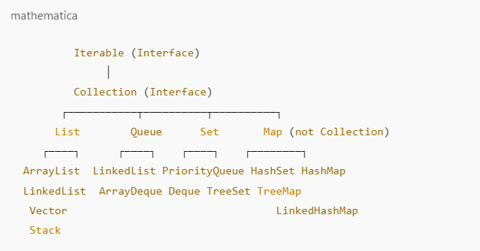

**Explanation of the Java Collections Hierarchy:**

**• Iterable Interface**

* Root interface that allows iteration using a loop.
* Implemented by Collection and other sub interfaces like List, Set, and Queue.

**• Collection Interface**

* Extends Iterable and is the parent of all collection types.
* Methods: add(), remove(), contains(), size(), isEmpty(), etc.

